**BTEC Extended Certificate**

in Creative Digital Media Production

**UNIT 11: Animation for Digital Media**

**TASK 1**

**Learner’s Name: Aaron Coleman**

**Learner declaration**

I certify that the evidence submitted for this assignment is my own. I have clearly referenced any sources used in the work. I understand that false declaration is a form of malpractice.

**Learner signature:acoleman313@howcollege.ac.uk**

**Date: 15/04/2016**

**UNDERSTANDING ANIMATION TECHNIQUES AND USES**

# How animation works

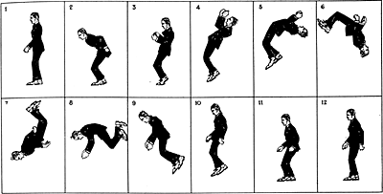Animation is done in many different ways a few of these will be discussed here first one I shall be talking about is the illusion of movement this works by tricking your brain into thinking something is moving when in reality it is not this can take the form of many things but one of the most known is the flipbook in which still images are drawn one many bits of paper so when you flick though them they are moving this is a type of beta movement persistence of vision is where discrete images blend together into a single image this is used in animation to give a sense of motion perception. The second thing that will be discussed will be something that is talked a lot about especially in the gaming genre which is frame rate which is measured in frames per second this is the speed in which the images are seen consecutively at something like 12 frames per second the image is slow and has latency issues well at 60 frames per second it is more smooth anywhere below 12 and it is not an animation as it is not moving. The last thing on this topic that I will be speaking about is the suspension of disbelief this is where something happens that is possible in our world built is in the animation a popular example is Tom and Jerry the characters inside that animation have been hit with frying pans in the face so there faces are flat and then just get up and continue.

# The development of animation technology

## Early animation technology

In the early animation era there was no television or cinemas because they had not been invented yet so animation was done in a different way one of the ways they did this was a phenakistoscope this is a disk in which when it is spun it makes an image move today that’s not a big deal as we have films and television but back then no one had seen a moving image then there was the zoetrope which was a sort of circle with patterns drawn on to it with something to spin it with and you would look thought the splits and see a moving image. The praxinoscope was like the zoetropin its design except it used a candle and patterned lamp shade to make the moving image. As well as these three there were three more the zoopraxinoscope was like the phenakistoscope except it was on a glass disk the kinetoscope was an early motion picture device that allowed an individual to see a moving picture though a small peephole and the cinematograph is a device that is used as a film projector and Pinter this was the first projector and while it was very basic and the films were seconds short it was still a big step in animation and film technology

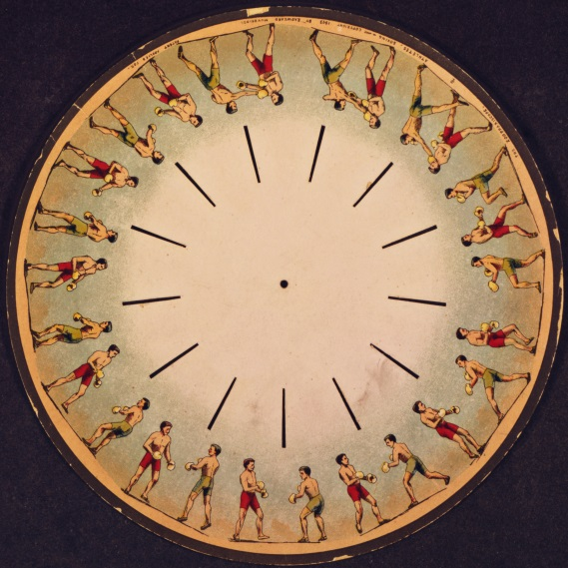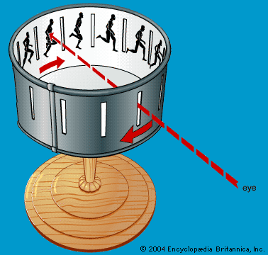

Phenakistoscope zoetrope

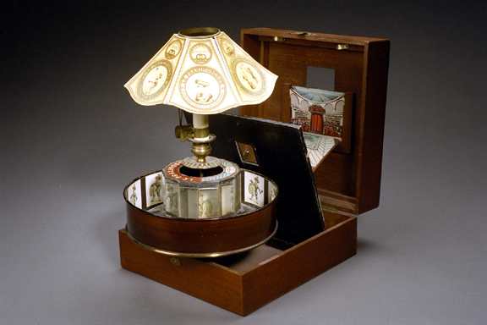 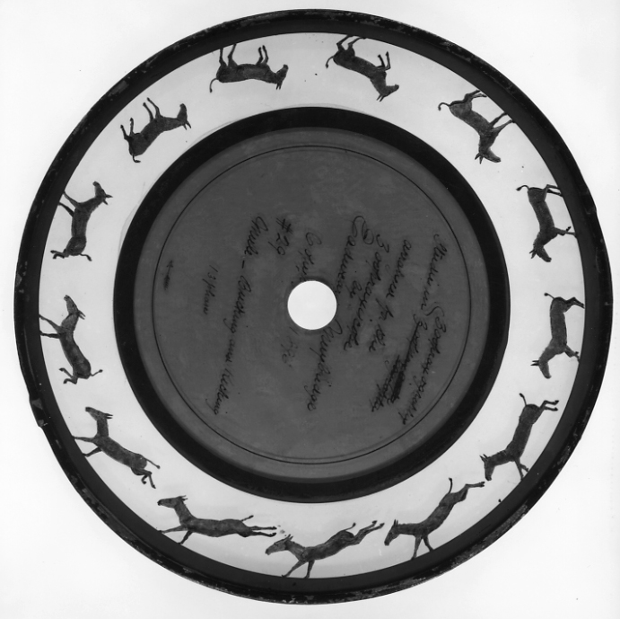

Praxinoscope Zoopraxinoscope

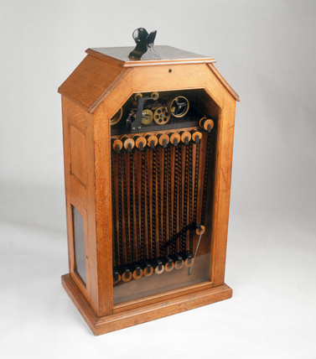 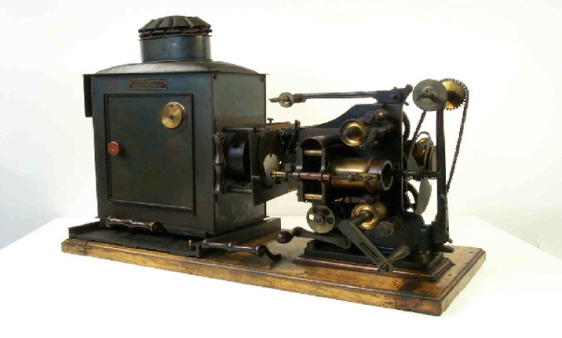

Kinetoscope Cinematograph

## Hand drawn animation

In the beginning of animation there was hand drawn animation this was done frame by frame object by object this was called cels and there would most likely be a ton of cells an example of this was snow white the first feature length animation there was up to 25 cells per frame this is how they would make a cel they would start with the sound that would be used count the frames it would take for each speech and then draw what would happen in the video after this they would paint the paper to give it colours depending on what the image was supposed to be after that they would dry them all before they would start taking individual photographs of the drawings for each frame this process was very lengthy and was known as cel animation translucent paper was used for this animation as you could put it over an existing drawing to draw another object to get it in the right place for each frame this would make it less difficult to draw frame for frame from memory which was almost impossible

## Sound in animation

At the start of animation the only sound they had was background music this was because they didn’t know about sound effects or how to impute dialogue this music was usually classical and was not copywriter and was only there so it wasn’t just silent after this there were special effects the first animation to use this new thing was Disney’s willy steamboat which had effects such as the whoosh and the horn of the steamboat this was big as there was more immersive sound effects it made it more entertaining dialogue was put in later on and it is what is used in today this was used in cel animation as well it was used to show what the artist had to draw for each cell because if this was done before the audio will be out of sync and it will not be entertaining or make any sense.

## Digital animation

Digital animation is animation done with a computer this is achieved by using many different software such as flash, 3DS max and many others this is much easier and faster than the classic method of drawing frames one by one it may be more expensive because of the technology but the finished product is well worth the price this is shown in the movie Toy Story which cost 30 million USD to make but has since grossed over 361 million USD worldwide and this movie was the first feature length animation. 2D animation is made by using shapes and moving them across a background this makes simple animations such as moving pictures or gifs but is not used by feature length animations because it’s too simple and the possibilities are very small another type of animation is 3D animation this is animation using models such as toy story or cars but it’s not limited to cartoons the movie avatar had a lot of animation in it 3D animation leaves the door wide open for anything as something that would usually cost a few million to make a scene can be done for a couple of thousand pound 3d character animation is done using a suite that is called a motion capture suit this is used to capture any movement and expression made for a character in the film or game this is used in games such as the last of us and in movies like avatar this motion capture is also known as performance capture.

# Animators

## Pre-digital era

Walt Disney was known as the pioneer of the American animation industry and has since his passing made the biggest name in animation ever his company Disney as produced many classics such a peter pan and Cinderella but Disney was also the first maker of a feature length hand drawn animation which was snow white at first all the animations made by Disney were hand made using cel animation but later on began using computers this was a little after the technology was created as Disney believed that animation by hand was cheaper and better than using machines Disney’s main character and its staple is micky mouse who was not always known as micky mouse he was first Oswald the lucky rabbit but was changed later on possibly inspired by a pet mouse Disney had adopted Walt Disney’s legacy is one that is very big Disney compared to say for example Len lye is like comparing a bowling ball to a golf ball Disney is more well known today then Len lye because while Len lye’s work was fantastic Disney has become a household name and nobody who owns a television or a computer does not know his name while before this day I had never heard of Len lye

## Post-digital era

John Lasseter is the [chief creative officer](https://en.wikipedia.org/wiki/Chief_creative_officer) of [Pixar Animation Studios](https://en.wikipedia.org/wiki/Pixar), [Walt Disney Animation Studios](https://en.wikipedia.org/wiki/Walt_Disney_Animation_Studios), and [Disney Toon Studios](https://en.wikipedia.org/wiki/DisneyToon_Studios) and is responsible for many animated favourites such as toy story and a bugs life john Lasseter used to work for Disney as an animator and suggested that computer animation should be used instead of cel he was sacked because of this and went to work for Lucas film and when the graphics design division was sold to Steve jobs he worked for Pixar and has since worked and created many famous films like the ones mentioned above compared to someone like Tim burton john Lasseter is of far greater importance because without him there would not be some of the childhood favioutes that both young and old alike would enjoy while Tim burton’s animation is quite dark and so he is not as popular or known of much but is mainly known for the night mare before Christmas and the corpse bride

# Where animation is used

## Example 1

Cel animation as mentioned above is a type of animation where multiple sheets of translucent paper like material called cells are drawn then staked together to create an image multiple stacks of cells are used to create an animation in the case of snow white which was the first feature length animated movie it took 10s of thousands of cells to create the movie and to this day it is widely loved because the animation in it was of an immense value it was smooth even though all the cells were hand painted the genre of snow white was a fantasy princess story that was aimed towards young and old alike snow white used the cel animation as computers were not around in those times as they were not invented for another 40 years compared to toy story which was made by computer you can see the difference but snow white is still able to hold up against that as there’s no way a silly error like hair falling though a shoulder can possibly happen but it takes a lot longer to make something using cel animation but it’s still as effective because even to this day people watch it and its still loved o to last all these years with so many people still watching it it must be effective.

## Example 2

Csgo is a first person shooter developed and published by valve the animation in this game has been made to be as realistic as possible so when you press w they run realistically like a normal person running as opposed to super Mario 64 where Mario s running is like he’s leaping or when he jumps he can do a double jump in the air while in csgo they can only jump one but there are a few animations that are missing such as going prone which is not possible but is strange for a first person shooter maybe it was not put in to keep balance as well as climbing this animation was made using software which allows people to animate characters such as 3ds max and then the game is then programmed with that animation when a certain button is pressed the target audience is people who like first person shooters that are more realistic and when the guns recoil is actually there and you can’t run and gun its aimed at 16 and above as well. The animation is csgo is very effective as it makes you feel more immersed in the game as opposed to call of duty where everything is flashy and sparkly csgo is realistic and is what would actually happen in a warzone.

# http://media.steampowered.com/apps/csgo/blog/images/posts/SecondaryGrenade.JPGReferences

**Flick book** cwestgate1.workflow.arts.ac.uk date accessed 15/04/2016

Phenakistoscope commons.wikimedia.org date accessed 15/04/2016

Zoetrope zeotropic.wordpress.com 15/04/2016

Praxinoscope [www.geh.org](http://www.geh.org) 15/04/2016

Zoopraxinoscope <https://en.wikipedia.org/wiki/Zoopraxiscope> 15/04/2016

Kinetoscope [www.ssplprins.com](http://www.ssplprins.com) date accessed 15/04/2016

Cinematograph <http://www.nationalmediamuseum.org.uk/collection/cinematography/viewingprojection/collectionitem?id=1990-5036/7965> date accessed 15/04/2016